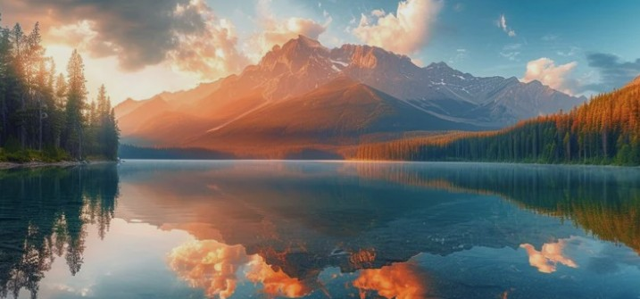
Accommodations
About Us
Activities
Dining & More
Home
MOFFAT BAY LODGE

Log In
Resume Your Adventure at Moffat Bay

Email Address:
Password:

Log In

Don’t have an account? Create one here

